**LETSUPGRADE LINUX ADMINSTRATION**

**Assignment 1, Day 3 | 2nd December 2020**

Question 1

1. Create a blank file named "myfile"
2. Open "myfile" in vi editor

3. Write your name, address, email id, phone number and blood group in 5 different lines

4. Build one single expression to see the line with your name and blood group in myfile

**ANS 1 .**

Creating myfile By Using touch command

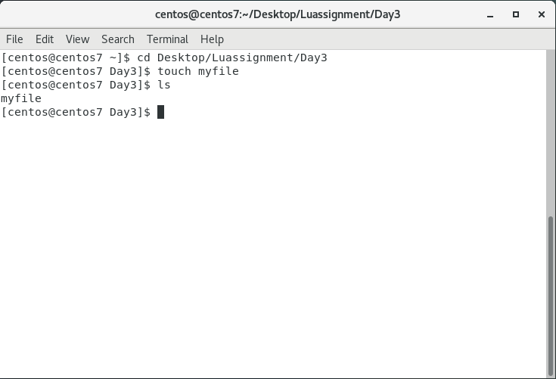

**ANS 2.**

Opening The File Using Vi Editor

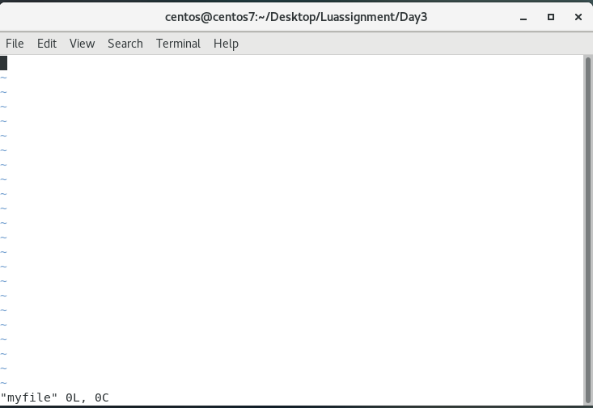

**ANS 3 .**Writing The Details And Saving It By Using :wq! Then Opening It By Using **cat** command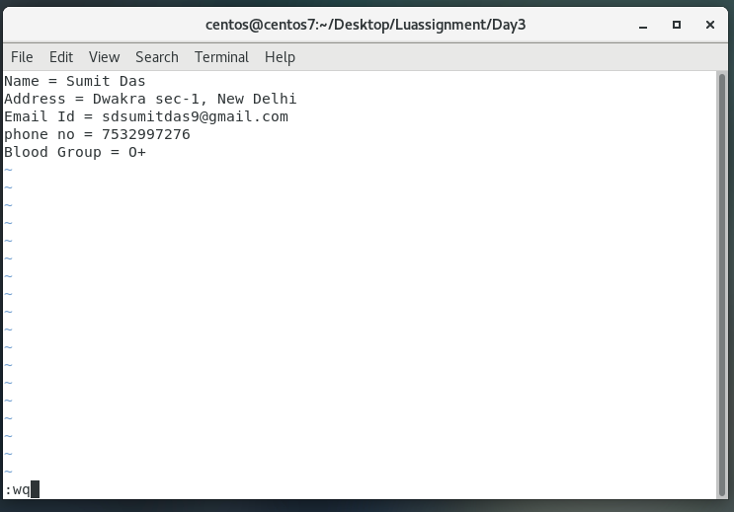

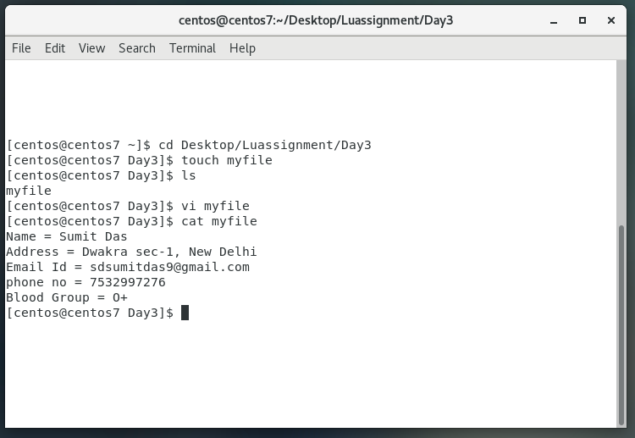



**ANS 4.**

Creating one single expression to find the name and blood group line

